TOPIC 7: SPEED, VELOCITY AND ACCELERATION
OBJECTIVES:
At the end of this class, students should be able to:
- Differentiate between speed and velocity.
- Define Acceleration.
- Carry out calculations involving speed, velocity or acceleration.
- Explain distance-time graph and velocity.
CONTENT
SPEED:
- This is the distance traveled per unit time.
i.e. Speed = $\frac{distance}{time}$
- Being the ratio of two scalar quantities. It is also a scalar quantity.
- It is considered as the magnitude of velocity.
- It described how fast a body moves.
- A body moving with constant speed is said to have “uniform speed”.
- If the speed of a body is not constant, then we consider:
- Instantaneous speed: This is the speed of the body at a particular instant of time.
- Average speed: this is the ratio of total distance traveled by the body to total time taken.
- Speed is also obtained as the gradient of distance – time graph.
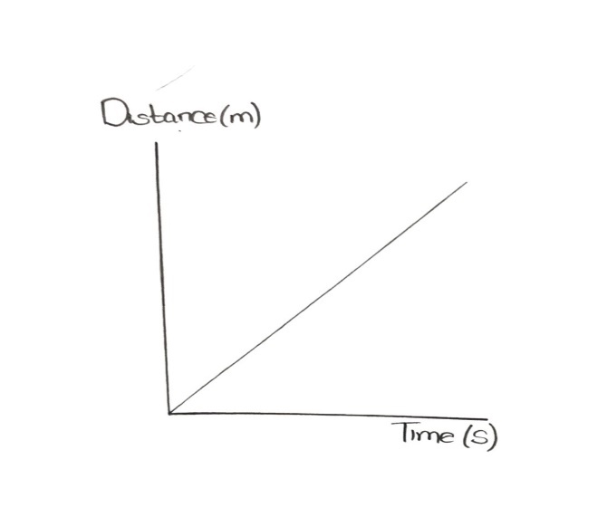  Uniform Speed | 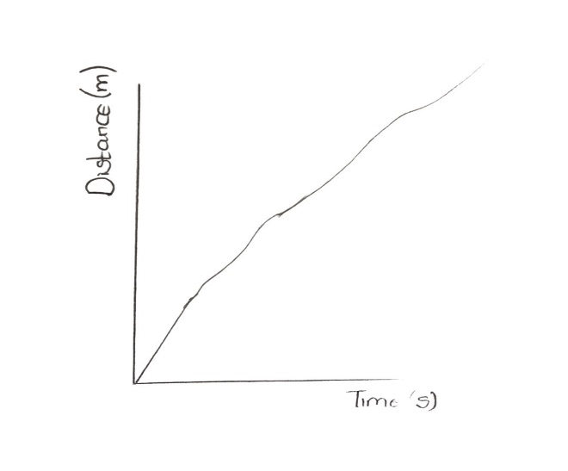  Non-uniform speed

VELOCITY:
- This is the displacement of a body per unit time
i.e. Velocity = $\frac{displacement}{time}$
- it is a vector quantity i.e. it has both magnitude and direction.
- Its magnitude is described as the speed of the body.
- Its direction is the same as the direction of the displacement.
- A body moving with constant velocity is said to be described as “Uniform motion”.
- It is also obtained as the gradient of displacement-time graph.
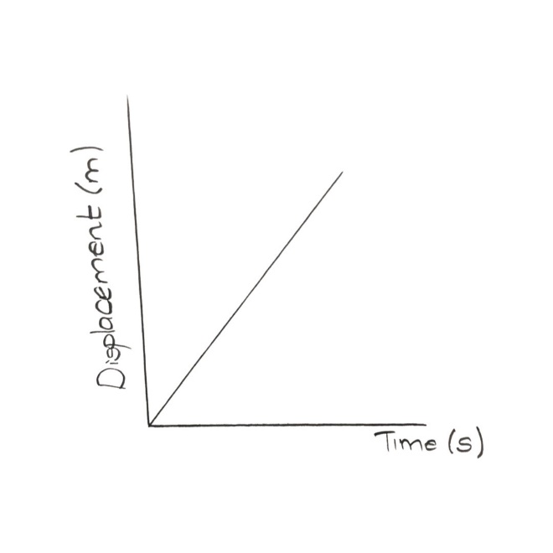  Uniform Velocity | 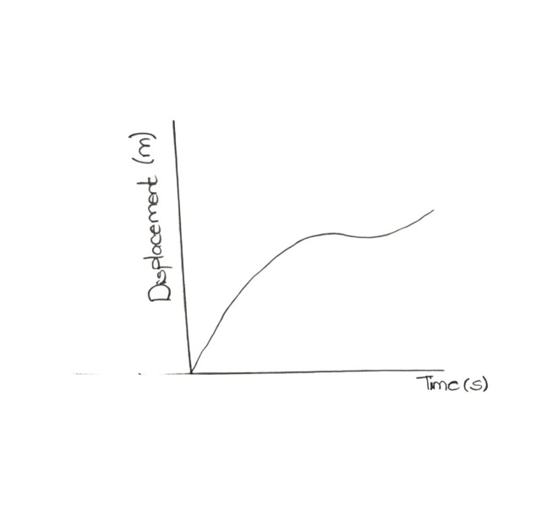  Non-uniform velocity

- The S.I unit for both speed and velocity is m/s.
ACCELERATION:
- This is the rate of change of velocity with time.
- It is positive when velocity increases.
- It is negative when velocity decreases and it is described as declaration/ retardation.
- It is zero when velocity remains unchanged.
- A body at rest also has zero acceleration.
- It is a vector quantity.
- Its S.I unit is m/$s^{2}$.
- If a body changes its velocity from U to V in time T, then acceleration is given as
a = $\frac{V-U}{t}$
- It can be obtained as the gradient of velocity-time graph.
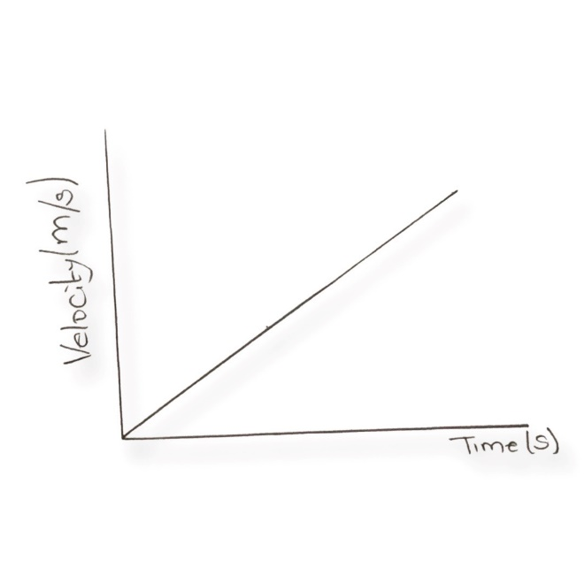  Uniform Acceleration | 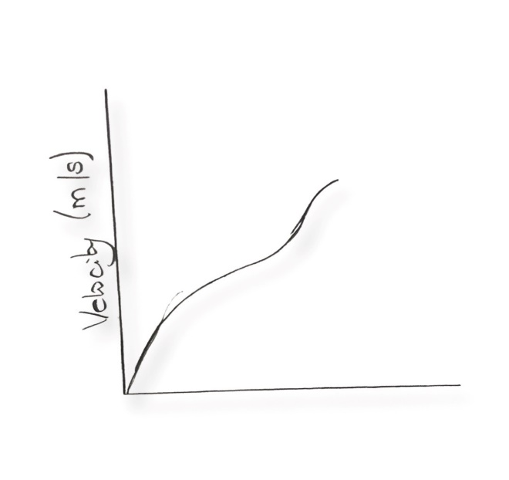  Non-uniform Acceleration

- Another important parameter in velocity-time graph is the area under the curve which represent the displacement / distance in a specific direction.

CALCULATIONS
Example 1: a particle covers a distance of 20m in 4s. Calculate the speed of the particle.
Solution:
Speed (v) = $\frac{distance (s)}{time (t)}$
V = $\frac{s}{t}$
Where s=20m, t= 4s
V = $\frac{20}{4}$
V = 5m/s
Example 2: A boy walks at 3m/s for 2s, 5m/s for 1s and then 3m/s for 2s. Calculate the average speed of the boy.
Solution:
Average Speed = $\frac{Total distance }{Total time }$
We can tabulate the information as shown below:
V (m/s) | T (s) | S (m)
3 | 2 | 6
5 | 1 | 5
3 | 2 | 6
 | 5s | 17m

Average speed = $\frac{17}{5}$
= 3.4m/s
Example 3: A body accelerates uniformly from 4m/s to 10 m/s in 3s. Calculate the acceleration of the body
Solution:
Initial velocity: U = 4m/s
Final velocity: V= 10m/s
Time: t=3s
a = $\frac{V-U}{t}$
a = $\frac{10-4}{3}$
a = $\frac{6}{3}$
a= 2m/$s^{2}$

DRILL
- A car is moving on a straight road at a constant speed in a single direction. Which of the following statement is true?
- Average velocity is zero
- The magnitude of average velocity is equal to the average speed.
- The magnitude of the average velocity greater than the average speed.
- The magnitude of the average speed.
- Four bicyclists travel different distances and time along a straight path. Which cyclist traveled with the greatest average speed?
- Cyclist 1 travels 95m in 27s
- Cyclist 2 travels 87m in 22s
- Cyclist 3 travels 106m in 26s
- Cyclist 4 travels 108m in 24s.
- What is the slope of a straight-line graph of position VS time?
- Velocity
- Displacement
- Distance
- Acceleration

- A car travelling at 10m/s is travelling at twice the velocity 10s later. If you made a graph of this motion. What information would be obtained from the area under the graph?
- The rate of acceleration of the car.
- The area enclosed by the car’s trip
- The car’s displacement during the 10s.
- The velocity of the car at t=10s.

